

The Sustainability Assessment Model (SAM)

David Cutteridge - Inchferry Consulting

Introduction

Sustainable Development (the journey to a sustainable society) is becoming increasingly seen as a critical issue for present and future generations.

The Sustainability Assessment Model (SAM) measures how the activities of a project, organisation or industry sector are contributing to Sustainable Development. The SAM originated in BP in 1999. Since then the SAM has been developed by BP, Genesis Oil and Gas Consultants, Inchferry Consulting and the University of Aberdeen.

The SAM is a tool which measures the social, environmental, economic, and resource usage impacts over the full life cycle, including supply chain and product use. The SAM measures the impacts through 22 performance indicators. The SAM approach is unique in that it monetises all these performance indicators, allowing for comparisons on a like-for-like basis.

SAM has been used to assess the performance of a range of UK oil and gas developments. It has also been used to evaluate energy extraction from an existing landfill, a tree planting scheme and a salmon farm. Additionally it has been used to assess the performance trends of the UK oil and gas industry. SAM is currently being developed by Landcare Research for use on several projects in New Zealand.

Overview of the SAM

The 22 performance indicators are grouped to assess how the activities under review contribute to:

- Economic prosperity
- Resource availability
- Environmental quality
- Social progress

The economic indicators measure the total value of the activities split into CAPEX and OPEX, taxes, dividends, social investment and profit.

The resource use impacts capture the intrinsic or inherent values of the resources used. These resources include natural consumable resources (e.g. oil, gas, water, steel, energy, etc.) as well as intellectual capital and infrastructure.

Environmental impacts from the activities are split into four elements: pollution (e.g. from combusting fossil fuels), footprint and biodiversity, nuisance (such as noise, odour and visual impacts) and wastes.

The social impacts have been estimated using three elements. Firstly, the social benefits arising from the direct and indirect jobs generated are estimated along with the associated negative health and safety impacts. The second element estimates the positive social impacts arising from the government spending of the tax revenues generated. The final element covers the benefits arising from the use of the products or services provided.

The 22 performance indicators described above can be combined by category to produce a “signature” which shows the positive and negative impacts which arise from the activities. It is then possible to convert the data in the signature into an overall measure of performance, the Sustainability Assessment Model indicator (SAMi). The target to achieve is 100% which would indicate that there are no negative Sustainable Development aspects.

Independent verification work of the tool has been undertaken by the University of Aberdeen.

Some Examples Using SAM

Signatures and SAMis for three different projects are provided here. A more comprehensive understanding of the projects can be obtained by investigating the 22 indicators in more detail.

1. A signature for a typical hydrocarbon development is shown below:

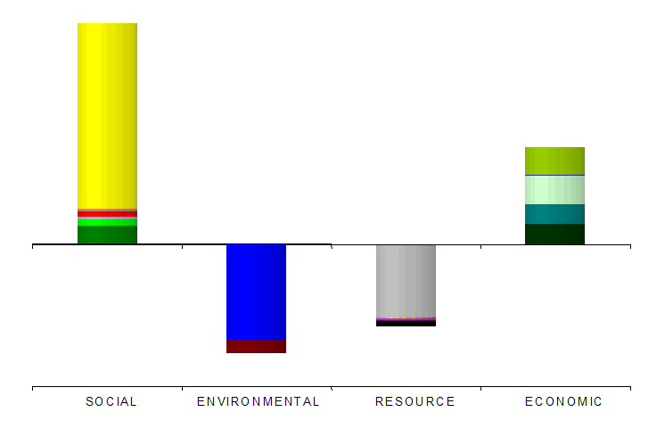

In this particular example three elements dominate:

- The social benefits arising from use of the products (mobility, heating and lighting, pharmaceuticals etc.)
- The environmental damage arising from the combusting of the hydrocarbons
- The resource usage of the in-place hydrocarbons

This hydrocarbon signature leads to a SAMi of 26%.

2. A signature for a landfill project is shown below:

The scope of the project was to use methane from an existing landfill to generate electricity. Because the landfill was already in existence, the impact of the project was to change the form of air pollution. Instead of the landfill emitting methane (with its high global warming potential) the project would emit less damaging CO₂ when the methane was combusted. The change in the form of pollution, therefore, leads to a net environmental benefit arising.

This landfill signature leads to a SAMi of 66%.

3. The signature for a tree planting scheme is show below:

The signature is dominated by the environmental benefits of the forest. This has two main components:

- The reduction of CO₂ levels
- Improved biodiversity

This tree planting signature gives a SAMi of 94%.

Summary

The SAM is a unique model for assessing contribution to Sustainable Development over a full life-cycle. The SAM is a versatile and easy-to-use tool which makes visible the significant factors which affect Sustainable Development. This visibility leads to an increasing awareness of Sustainable Development issues, which in turn influences behaviours, thus improving decision making.
The SAM can be used to:

- Assess project performance and also to allow comparisons between, and therefore ranking of, projects.
- Inform specific design decisions such as development scheme selection, concept selection or decommissioning scheme.
- Assess the overall Sustainable Development performance of an industry sector. This could be on a one off basis or to assess performance trends of the sector.
- Assess an organisation’s overall performance thus informing the direction of, both short term and long term, company strategy.
Further information on SAM can be obtained from David Cutteridge of Inchferry Consulting – david@inchferry.co.uk or 01224 734406

